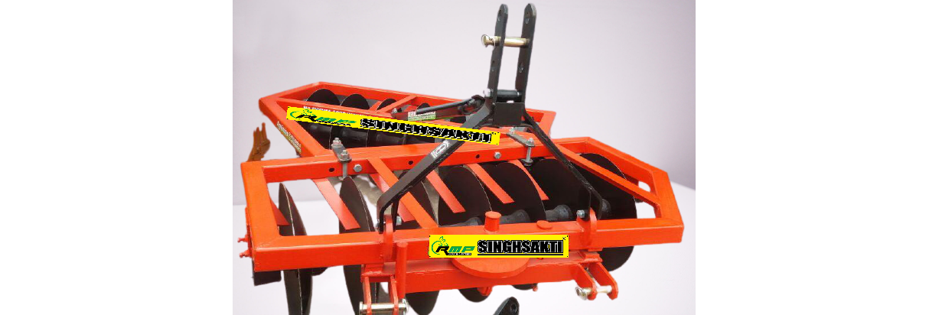 **Disk Harrow**

Features & Benefits:

* Heavily weighted gangs provide excellent stability -compatible with a variety of tractors.
* Can be used for both, surface disc harrowing (superficial ploughing) and intensive deep ploughing.
* Used in open field working for shattering of clods, preparation of soil for sowing and burial of organic substances and crop residue.
* Easy gang adjustment to change the cutting depth and to get the perfect level finish.
* Easy to transport using the wheel attached to the harrow frame.
* Available with the options of high carbon steel discs and high quality boron steel discs with 48-52 HRC hardness.
* High quality bearings and hubs ensure smooth operation and put minimal load on the tractor.
* High quality seals prevent the entry of mud and water into the bearings and hubs.